Committee Member
Application Pack

Closing date for this recruitment cycle :
Monday 15 February 2026


Molendinar Park Housing Association, 3 Graham Square, Glasgow G311AD

Tel: 0141-564 5256 • E-mail: admin@molendinar.org.uk • Web: www.molendinar.org.uk

Registered in Scotland - 2400 R (S) • Registered Scottish Charity SC043725 • Registered Property Factor PF000125

Contents
Welcome to Molendinar Park Housing Association 1
1. Background 2
2. Our Strategic Objectives 4
3. Our Staff Structure 5
3. Our Committee Structure 6
4. Role Description for a Committee member of MPHA 7
5. Our Commitment to Equalities 11

Welcome to Molendinar Park Housing Association
We’re delighted that you’re interested in joining our Management Committee. This position offers a meaningful opportunity to support the important work of our Association, helping us deliver high-quality housing services for our tenants and make a positive difference within our communities.
In this pack, you’ll find the job description, background information about MPHA, and the person specification for the role of Committee Member. These materials are designed to help you understand what we’re looking for and how your skills, experience, and enthusiasm could contribute to our governing body.
We look forward to receiving your application.
We look forward to receiving your application.
If you have any questions about the role please call Susan Paton for an informal and confidential chat 0141 564 5256 or susanpaton@molendinar.org.uk

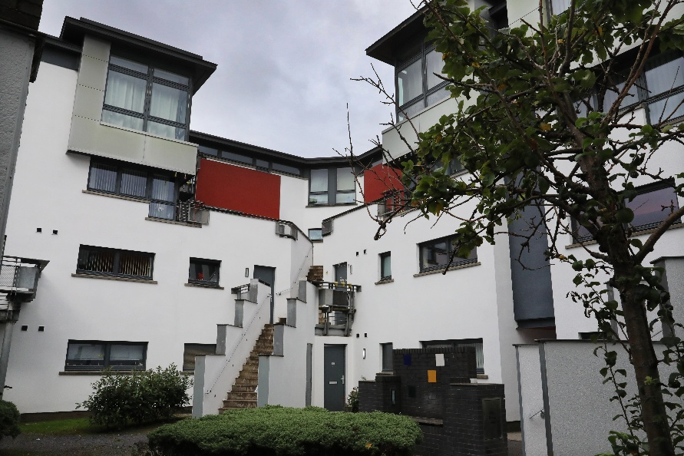

Background
MPHA is a registered social landlord, a Scottish charity and registered property factor. We are led by a voluntary Management Committee that currently has eleven members: ten members who live locally, of which five are MPHA tenants. MPHA owns 497 properties and provides factoring services to 250 owner-occupiers. We also manage 78 shared ownership properties.
Since our formation in 1993 MPHA has built 268 new flats and renovated a tenement building in the Bellgrove area. The Association has won several awards for its developments in Bellgrove. In 1999 we purchased a Sheltered Housing Complex in Castlemilk and a small development around Finnart Square in Bridgeton from Scottish Homes. A year later we purchased 350 houses from Scottish Homes in Dalmarnock.
Our communities have high levels of deprivation and inequality. Glasgow’s east end is also home to high levels of housing-led regeneration, and there has been a sustained increase in population which is continuing due to current new build development by social landlords and private developers.
Since 2020, MPHA and its tenants, like all other social landlords, have been confronted with a series of unexpected and significant challenges. Our response to the pandemic was swift and effective: we maintained services to our tenants throughout, whilst complying with all legislative requirements and good practice advice. We achieved compliance with new fire safety and energy efficiency standards as required and did not build up a significant backlog of routine or planned maintenance work. Our arrears were managed successfully and did not increase. No staff were furloughed; our staff supported tenants effectively whilst also working flexibly and constructively from home. We maintained good working relationships with our contractors, most of whom are local, and their co-operation was critical to our successful maintenance of responsive and planned maintenance services and sustained good performance.
Our ability to adapt and respond successfully to these unexpected challenges is rooted in the solid foundations that underpin this Business Plan:
- Strong governance
- An experienced and committed staff team
- Excellent performance results for service delivery
- Very high levels of tenant satisfaction with our services
- A positive attitude to making changes and improving how we work
- Low levels of debt and a healthy cash position, which will enable us to invest in tenants’ homes, maintain affordable rents and stay resilient in the face of economic uncertainty.
We have a vision and mission for the future, as set by the Management Committee in our current business plan for 2025-2027:
Molendinar Park Housing Association aims to sustain and create thriving communities across all of our stock areas. We will do this by:
- Pursuing excellence in service delivery for our customers
- Investing effectively in our tenants’ homes and neighbourhoods
- Being open and accountable to our tenants
- Investing in our people

We will be satisfied that our Mission and Vision are being achieved with these results:

Pursuing excellence in service delivery for our customers
Our tenants and customers are satisfied with their homes, neighbourhoods and our services. We respond quickly to repairs and complaints which we aim to resolve ‘right first time’. Our performance is in the top quartile for the sector.

Investing effectively in our tenants’ homes and neighbourhoods
Our planned and cyclical maintenance services are delivered to meet all national standards and ensure tenants’ homes are affordable and as efficient, warm and secure as possible.

Being open and accountable to our tenants
We talk to our tenants and agree standards for our services that reflect what is important to them. We report our performance regularly to our tenants and consult about how we deliver services to keep pace with changing needs and expectations.

Investing in our people
We empower our staff to deliver excellent services to our tenants and customers through continuous support, learning and professional development. Our Management Committee has an appropriate range of relevant skills, knowledge and experience and all members take part in ongoing learning and development.
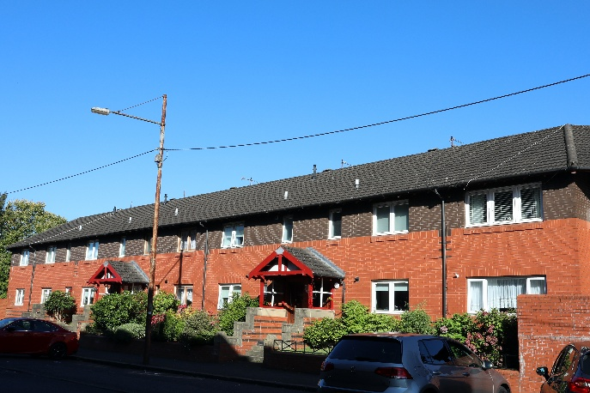

2. Our Strategic Objectives
The Management Committee has set six strategic objectives which are:
Successfully achieving these strategic objectives will be evidenced as follows:
- Serve our Tenants – we provide affordable, well-managed homes which comply with all relevant safety and quality standards. We are responsive to our tenants and seek to understand and meet their expectations in what we do and how we operate.
- Invest Effectively – we plan our maintenance programmes to ensure that our tenants’ homes continue to be high quality, desirable and safe places to live. We support local contractors by working with them to deliver our services and sustain the local economies. We learn from innovation and use our experience and knowledge to ensure that we deliver value for money for our tenants and customers.
- Engage Openly – we communicate effectively and constructively with our tenants and residents. We consult with our tenants about the ways we communicate. We ask for feedback about what we do and how we perform, and we use this to improve and develop our services.
- Create and support desirable and sustainable communities – we aim to be more than a landlord by working in partnership with other agencies to ensure our tenants and residents have access to information, advice and support. We will support neighbourhood initiatives that are focussed on improving community facilities and well-being. We will consult with our tenants about how they would like us to do this, recognising that individual communities have different priorities.

- Deliver our promises – we protect our tenants’ interests by setting and achieving high standards that are among the best in the sector. We are focussed on being financially sustainable whilst maintaining rents at levels that are affordable to our tenants and generate sufficient income to meet agreed standards and our long-term responsibilities. We ensure that governance is strong by adopting a prudent approach to risk, being accountable to our tenants, funders and regulators, complying with their requirements, ensuring that our management committee and staff are well equipped to meet our objectives through continuous learning and development.
- Invest in our People – we provide training, support and a collaborative working environment to attract and retain highly competent and strongly motivated staff who are focussed on providing excellent services to tenants. We recruit committee members who are committed to MPHA’s aims and objectives and those of the social rented sector and who have relevant skills, knowledge and experience and who participate in ongoing training to ensure that MPHA’s governance and management are robust, compliant and reflect good practice.

3. Our Staff Structure
You will be part of a small and friendly dedicated team.

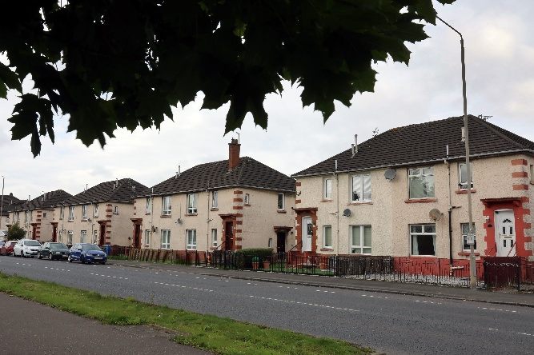

3. Our Committee Structure
Our rules permit a maximum of fifteen committee members. We currently have 10 members. The Management Committee intends to recruit additional members during this business planning period as part of its ongoing succession planning. Members can be either share-holding members who are elected at the AGM or people with experience who can be ‘co-opted’ to the committee. Not more than one third of members can be co-opted: there are no co-optees currently.
- The Management Committee usually meets ten times a year with no meetings in July or December.
- The Committee holds an annual Away Day which is also attended by staff: it provides an opportunity to review progress, consider new initiatives and agree future plans and priorities.
- As well as the main management committee we have a Services Sub Committee that looks at performance of our operational areas - maintenance, housing management, tenant & resident safety and procurement.
- We are members of SFHA, Glasgow and West of Scotland Forum and SHARE and these organisations provide committee members and staff with access to good practice advice, good quality training and sector information.

4. Role Description for a Committee member of MPHA
1. Introduction
“The Governing Body leads and directs the RSL to achieve good outcomes for its tenants and other service users.” Regulatory Standards of Governance and Financial Management, Standard 1
1.1 This role description has been prepared to set out the responsibilities that are associated with being a governing body member (GBM) of Molendinar Park Housing Association (MPHA). It should be read in conjunction with the accompanying person specification and MPHA’s Rules and Standing Orders.
1.2 MPHA is a Registered Social Landlord and a Scottish Charity. The role description reflects the principles of good governance and takes account of (and is compliant with) the expectations of the Regulatory Standards of Governance and Financial Management for Scottish RSLs and relevant guidance produced by the Office of the Scottish Charity Regulator (OSCR).
1.3 MPHA encourages people who are interested in the Association’s work to consider seeking election as a GBM and is committed to ensuring broad representation from the communities that it serves. GBMs do not require ‘qualifications’ but, from time to time, we will seek to recruit people with specific skills and experience to add to or expand the existing range of skills and experience available to ensure that the governing body is able to fulfil its purpose. We have developed a profile for the GB which describes the skills, qualities and experience that we consider we need to lead and direct MPHA and carry out an annual review of the skills that we have and those that we need to inform our recruitment activities.
1.4 This role description applies to all members of the governing body, whether elected or co-opted or appointed, new or experienced. It is subject to periodic review.

2. Primary Responsibilities
2.1 As a GBM your primary responsibilities are, with the other members of the governing body, to
- Lead and direct MPHA’s work
- Promote and uphold MPHA’s values
- Set and monitor standards for service delivery and performance
- Control MPHA’s affairs and ensure compliance
- Uphold MPHA’s Code of Conduct and promote good governance

2.2 Responsibility for the operational implementation of MPHA’s strategies and policies is delegated to the Director.

3. Key Expectations
3.1 MPHA has adopted a Code of Conduct for Governing Body Members which every member is required to sign on an annual basis and uphold throughout their membership of the governing body.
3.2 Each GBM must accept and share collective responsibility for the decisions properly taken by the governing body. Each GBM is expected to contribute actively and constructively to the work of MPHA. All members are equally responsible in law for the decisions made.
3.3 Each member must always act only in the best interests of MPHA and its customers, and not on behalf of any interest group, constituency or other organisation. GBMs cannot act in a personal capacity to benefit themselves or someone they know.
3.4 Our rules contain specific requirements that all GBMs should be aware of, including:
- The GB must have at least seven members
- The quorum for a meeting of the GB is four members, who must be elected or have filled a casual vacancy
- The quorum for a sub-committee meeting is three members, who must be elected or have filled a casual vacancy
- Co-opted members cannot make up more than one third of the GB; they do not contribute to a quorum being achieved and cannot be elected to an OB role
- The Secretary must present a report to the last GB meeting before the AGM confirming that all the requirements of Rules 62-67 have been met
- An experienced GBM (who has nine or more years’ experience with the RSL) must have the agreement of the GB if they intend to seek re-election for a further term: the GB’s agreement should be recorded in the relevant minute
- A GBM ceases to be a member of the GB if they miss four consecutive meetings without, first, having been granted leave of absence
- A GBM who has declared an interest in a matter to be discussed at a meeting must leave the meeting, before the matter is discussed, and cannot vote on the issue

4. Main Tasks
- To contribute to formulating and regularly reviewing MPHA’s values, strategic aims, business objectives and performance standards
- To monitor MPHA’s performance
- To be informed about and ensure MPHA’s plans take account of the views of tenants and other customers
- To ensure that MPHA operates in accordance with relevant legal and regulatory requirements
- To be assured that MPHA is compliant with relevant legal and regulatory requirements
- To ensure that risks are realistically assessed and appropriately monitored and managed
- To ensure that MPHA is adequately resourced to achieve its objectives and meet its obligations
- To oversee and ensure MPHA’s financial viability and business sustainability whilst maintaining rents at levels that are affordable to tenants
- To act, along with the other members of the governing body, as the employer of MPHA’s staff
- To ensure that MPHA is open and accountable to tenants, regulators, funders and partners

5. Duties
- Act at all times in the best interests of MPHA
- Accept collective responsibility for decisions, policies and strategies
- Attend and be well prepared for meetings of the governing body and sub-committees
- Contribute effectively to discussions and decision making
- Exercise objectivity, care and attention in fulfilling your role
- Take part in ongoing training and other learning opportunities
- Take part in an annual review of the effectiveness of MPHA’s governance and of your individual contribution to MPHA’s governance
- Maintain and develop your personal knowledge of relevant issues and the wider housing sector
- Represent MPHA positively and effectively at all times, including in local communities and when attending meetings and other events
- Respect and maintain confidentiality of information
- Treat colleagues with respect and foster effective working relationships within the governing body and between the governing body and staff
- Be aware of and comply with our policy on the restrictions on payments and benefits
- Register any relevant interests as soon as they arise and comply with MPHA’s policy on managing conflicts of interest

6. Commitment
6.1 An estimate of the annual time commitment that is expected from Committee is:
Activity | Time
Attendance at up to Molendinar Park HA regular meetings of the Committee | 2hours x 10 meetings
Reading and preparation for meetings of the governing body | 2 hours x 10 Meetings
Attendance at up to Molendinar Park HA sub-committee  meetings | 2 hours x 4 meetings
Reading and preparation for sub-committee meetings | 1 hour x 4 meetings
Attendance at annual planning and review events (including  individual review meeting) | 1 day (9-5pm)  1 hour for annual review
Attendance at events such as estate tours, tenant / customer  conferences, openings and site visits | Ad hoc/ 4 hours per Year.
Attendance at internal briefing and training events | 1 hour per month
External Training and conference attendance (may include  overnight stay or weekend) | 1 day (9-5pm)

7. What MPHA Offers GBMs
7.1 All GBMs are volunteers and receive no payment for their contribution. MPHA has adopted an Entitlements, Payments and Benefits (EPB) Policy which prevents you or someone close to you from inappropriately benefiting personally from your involvement with MPHA. This and related policies also seek to ensure that you are not unfairly disadvantaged by your involvement with MPHA. All out of pocket expenses associated with your role as a GBM will be fully met and promptly reimbursed.
7.2 In return for your commitment, MPHA offers:
- A welcome and introduction when you first join the governing body;
- A mentor from the governing body and a named staff contact for the first six months, with ongoing support
- Clear guidance, information and advice on your responsibilities and on MPHA’s work
- Formal induction training to assist settling in
- Papers which are clearly written and presented, and circulated in advance of meetings
- The opportunity to put your experience, skills and knowledge to constructive use
- The opportunity to develop your own knowledge, experience and personal skills
- The chance to network with others with shared commitment and ideals

5. Our Commitment to Equalities
We welcome applicants to join the Committee from all sectors of the community. We take equal opportunities very seriously and are committed to ensuring fairness and inclusion throughout our recruitment process. We welcome Committee applications from all candidates who think they fit the bill; regardless of age, disability, gender identity, marriage or civil partnership, pregnancy or maternity, race, religion or belief, sex, or sexual orientation.

If you need support to participate in the management committee please speak to the Corporate Services Officer to discuss accommodations that can be made to support you in developing this role.

Scottish Housing Regulator (February 2024) Regulatory Framework

